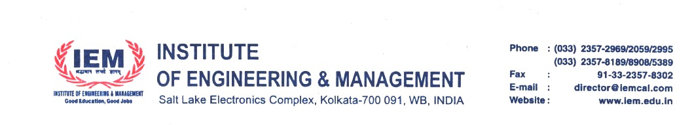

Notice for Students and Alumni members regarding Semester Scholarships

IEM Foundation USA along with IEM Alumni Association and UEM Alumni Association will be giving the following scholarships to 50 eligible current students and 30 eligible alumni members.

1. Current Semester Fees Scholarship to eligible regular students – One Time Scholarship

2. Alumni grant to eligible alumni members who are facing immense financial difficulty, due to job loss / hospitalization / natural calamity – One time grant of USD $700 (approx Rs. 50,000/-)

Eligibility: To avail the student semester fees scholarships or alumni financial grant, the current students and alumni members should send an application with cover letter, proof of job loss/proof of hospitalization/proof of business loss to the following coordinators of the respective alumni associations. The scholarships and grants (50 scholarships and 30 grants) will be judged by a committee of alumni members based on the applications received.

IEM, Kolkata – Prof. Dr. Sanghamitra Poddar – sanghamitra@iem.edu.in

UEM Jaipur – Prof. Dr. Biswajoy Chatterjee - biswajoy.chatterjee@uem.edu.in

UEM Kolkata – Prof. Dr. Susmita Mukherjee – susmita.mukherjee@uem.edu.in

Please mark a copy to pradip.ghoshal@iem.edu.in

Please apply by 31st July 2023 (5 PM).

Best Wishes,
Prof. Dr. Satyajit Chakrabarti

