Event: Women’s Day Celebration
Date: 8th March, 2022
Venue: ‘Natun Ghar’, Rabindrapally
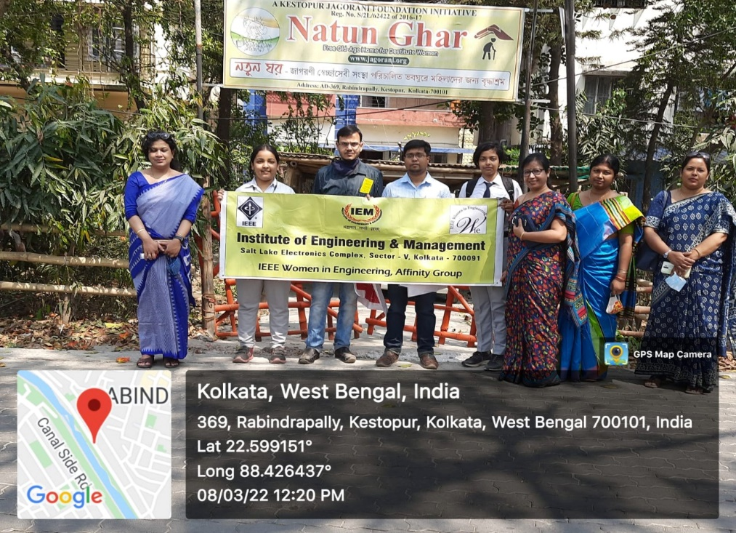

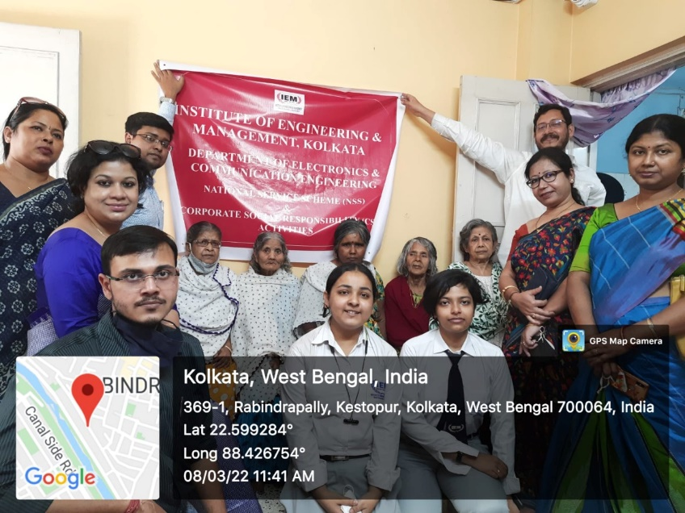
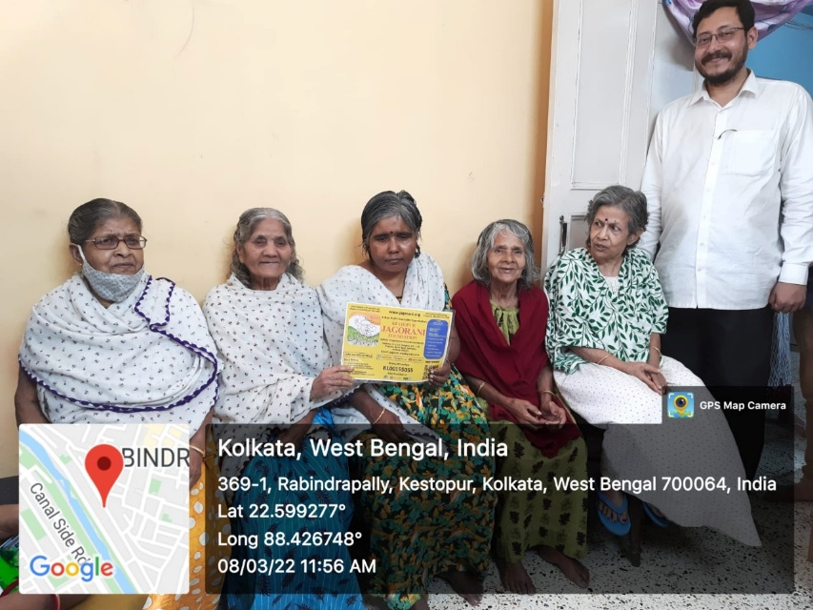
On 8th March,2022, IEM-ECE Department took an initiative for celebrating Women’s Day at ‘Natun Ghar’ , an old age home in Rabindrapally, Keshtopur, under the banner of IEEE WiE section and NSS & CSR Activities and Jagorani NGO.

Few professors of ECE Department- Prof. Ratna Chakrabarty , Prof. Mili Sarkar , Prof. Srijita Chakraborty , Prof. Samit Karmakar, Prof. Soumik Kundu and Prof. Aparna Biswas also participated diligently in this activity.

