
INSTITUTE OF ENGINEERING & MANAGEMENT
End Semester Lab Examination

Practical Group Allocation and Schedule for End Semester Practical Examination, December, 2020
DATE | COURSE | SUBJECT | TIME | ROLL NUMBER RANGE | FACULTY
07-12-2020 | M.Sc 3rd Sem | OR Lab [MCS391] | 9:30 AM - 12:30 PM | ALL | ALL
07-12-2020 | M.Sc 3rd Sem | OS Lab (Unix) [MCS392] | 1:00 PM - 4:00 PM | ALL | ALL

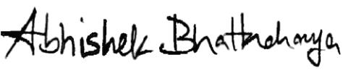

________________________________________

Prof. Abhishek Bhattacharya

HOD, Department of BCA and M.Sc(CS)

